Week 7 Notes

SQL

Database – systematic storage of related or closely related info, its equipped to manage large amounts of data in its structured format allowing users to store retrieve and update info easily, it is also conducive to analytics as well has multiple types of database for example relational database

Different types of database- relational database management system, in memory database (stored locally in RAM) RDMS are stored on the hard drive and solid state drive (ssd)

Sql – structured query language – programming language that allows users to interact with data stored in databases, you can create databases, create tables, update info, retrieve information

SQL Flavors – different types- commercial like oracle or ms sql server; open source—PostgreSQL, My SQL, SQL Lite

SQLite Storage Classes – null – the value is null; INTEGER – the value is a signed integer; REAL – value is a floating point; TEXT – value is a text string; BLOB- stored exactly as it is input

Importing data into DB

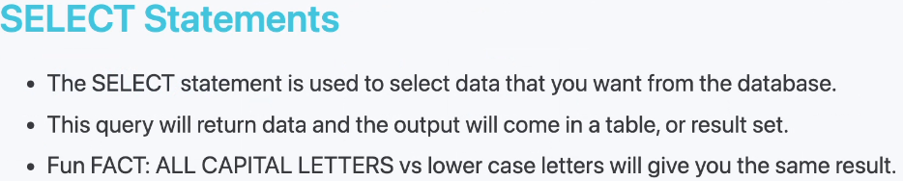

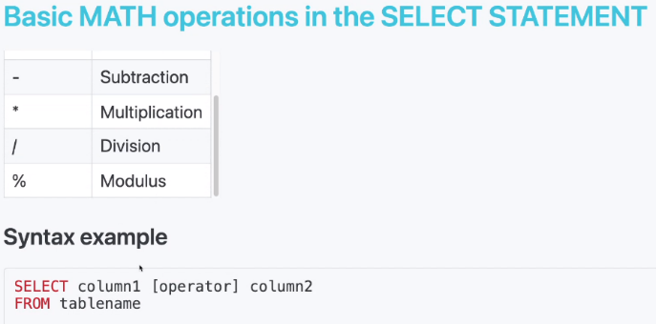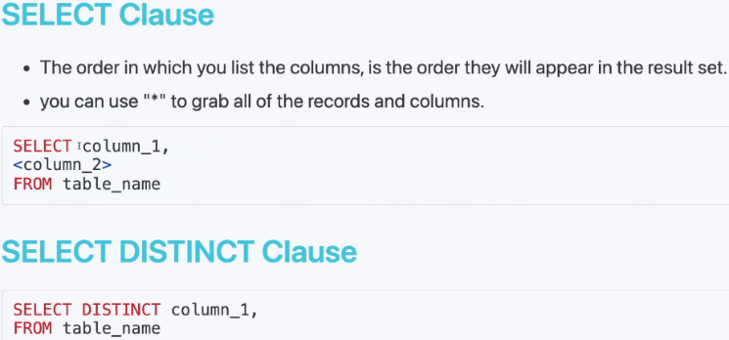

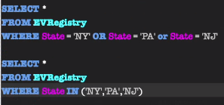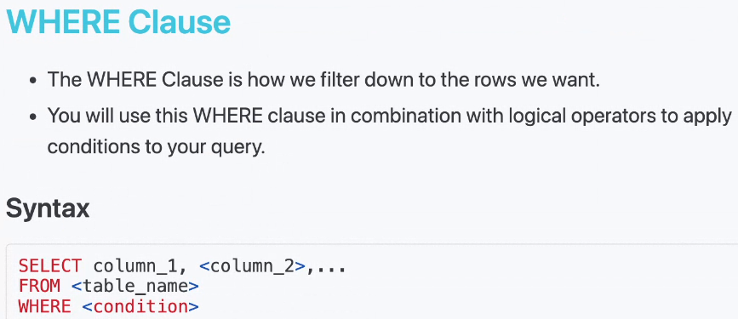

Day 2

----Done by using LIMIT #

